SUBJECT:MPA
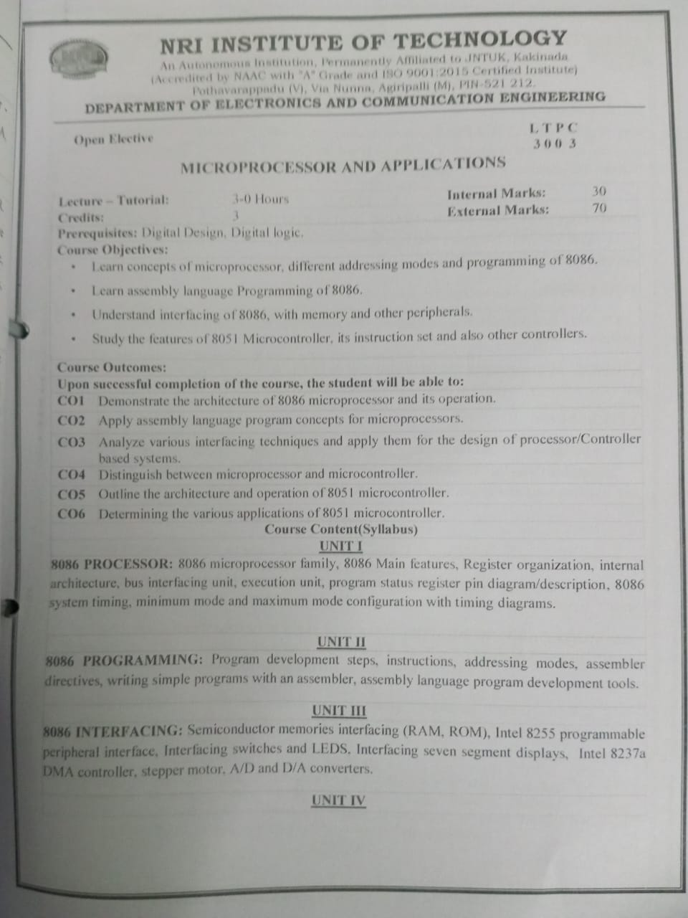

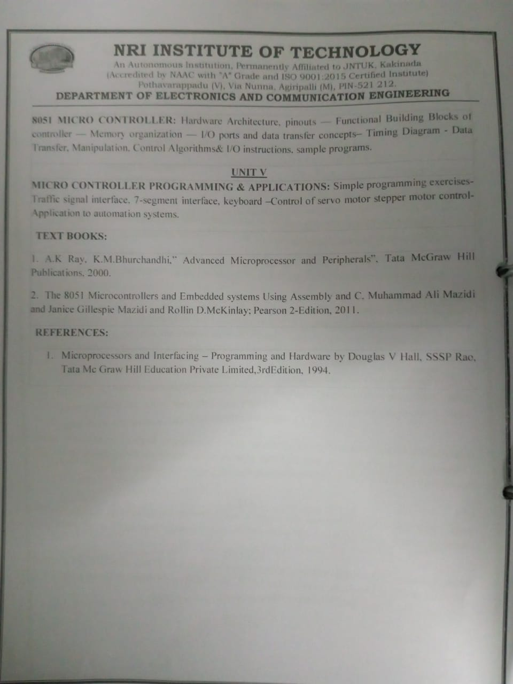

UNIT -1
Questions:
1. Explain the features of 8086?
2. Draw the Architecture of 8086 and explain each block?
3. What is the length of queue and explain the flag register with neat diagram?
4. What is segmentation? why segmented?
5. Explain the programming model (Register organization) of 8086?
6. Draw the diagram for minimum mode configuration and explain the read operation by using timing diagram?
7. Draw the diagram for minimum mode configuration and explain the write operation by using timing diagram?
8. Draw the diagram for maximum mode configuration and explain the read operation by using timing diagram?
9. Draw the diagram for maximum mode configuration and explain the write operation by using timing diagram?
10. Difference between minimum mode and maximum mode.
11. Explain the following pins:
a)NMI b)INTR c)READY d)TEST e)MN/MX f)ALE g)DT/R
h)DEN i)QS0/QS1
12. If CS=3814Hz and IP=2222Hz,What is the physical address?

UNIT-2
Questions:
1. What are programming development steps by using 8086?
2. Define addressing mode? And explain various addressing modes of 8086?
3. Write the arithmetic instructions of 8086 with an example?
4. Explain the following instructions?
a) NEG b) XLAT c) JC d) CALL
5. Write any data transfer instructions of 8086 with examples?
6. What is meant by assembler directive and write any five assembler directives?
7. Explain the following assembler directives
a) ORG b) DW c) EQU d) ENDS
8. Write an ALP to find the factorial of a given number of 8086?
9. Write an ALP to convert packed BCD to unpacked BCD.
10. Write an ALP to convert unpacked BCD to packed BCD.
11. Write an ALP to find the number of odd and even numbers of given series.
12. Write an ALP to find no of positive and negative numbers of a given series.
13. Write an ALP to sort given numbers in ascending order by using bubble sort method.
14. Write an ALP to sort given numbers in descending order by using bubble sort method.
15. Write an ALP to sum any five numbers in a series and also average in 8086.

UNIT-3
Questions:
1. Write about RAM and ROM memory organization?
2. What are address decoding techniques and explain?
3. Design an 8086 micro-processor based system having memory of 16k X 8 ROM and available chips are 8K X 8 only. Show the complete memory interface by using absolute decoding technique?
4. Design an 8086 based system with memory of 64k X 8 RAM by using linear decoding technique and available chips are 32K X 8 RAM?
5. In 8086 based system uses the following specifications?
a) 32K X 8 RAM b)32K X 8 ROM

6. What are the features of 8255 and draw the block diagram of 8255?
7. Explain the various modes of 8255?
8. Draw the control word register format of 8255 and explain each bit?
9. How to interface with LEDs through 8255? Write a program to display LEDs on and off for sometimes?
10. How to interface seven segment display with 8266 through 8255 and a write a program to display numbers from 0-9?
11. How to interface DAC 0800 with 8086 through 8255? Write a program to generate a square wave of 5Vp-p amplitude with 1KHZ frequency?
12. Write a program to generate a triangle wave from 4Vp-p with 1KHZ?
13. How to interface with ADC 0808 with 8086 through 8255 and write a program to convert an analog into digital voltage?
14. What is a stepper motor? How to interface with 8086 and write a program to rotate a stepper motor in clock wise direction by using full step sequence mode?
15. Write an ALP to rotate a stepper motor in clockwise direction up to 90 only the internal teeth on router is 180.Assume motor runs with full step sequence mode.
16. What is DMA? Write the features of DMA controller 8237? Draw the block diagram of 8237 and can explain?
17. What are the operating modes of DMA.

UNIT-4
Questions:
1. Differentiate the microprocessor and micro controller?
2. Draw the block diagram of 8051 and list the features of 8051.
3. Explain the following pins of 8051:
a) PSEN b) EA c)ANE d) INT0
4. Explain the internal organization of memory (RAM).
5. Draw the PSW register and explain each.
6. What is timer/counter and explain TMOD and TCON registers of 8051.
7. Explain the operational timer modes.
8. Explain SCON and PCON registers of 8051.
9. Explain various interrupts of 8051 and give the details of IE and IP registers of 8051.
10. What is an addressing mode and explain various addressing modes of 8051.
11. Explain the data transfer instructions of 8051 with examples.
12. Explain the arithmetic instructions of 8051 with examples.
13. Explain the various branch instructions of 8051 with examples.
14. Write an ALP to perform arithmetic operations in 8051 by using register indirect addressing mode.
15. Write an ALP to perform arithmetic operations in 8051 by using direct addressing mode.
16. Write an ALP to perform arithmetic operations in 8051 by using immediate addressing mode.
17. Write an ALP to find number of 1's and 0's of a given number 58H.
18. Write an ALP to find number of even numbers and odd numbers in a given series.

UNIT-5
Questions:
1. Explain the operation of traffic signal interface with 8051 and write a program to glow green signal for some time and red signal for some time?
2. How to interface seven segment with 8051 and write a program to display number from 0-9?
3. How to interface keyboard with 8051 and write a program to detect the pressed keys?
4. How to control the servo motor with 8051?
5. How to interface stepper motor with 8051 and write a program to rotate a stepper motor in clockwise direction by using full step sequence mode?
6. Write about applications to automation systems?

